- Let’s start by creating a work directory. Inside the work directory we will create a sub folder for each lab and in the Labxx folder we will create a sub folder for each part/function of the lab. It is important to stay organized, it will save you a world of pain later! I have created ‘path/Lab01/andgate2’. In this folder, save any verilog files that have been provided.

- Launch quartus, I like to ‘Run as administrator’. It has helped me avoid some problems with the simulator. You can also simply open the software.

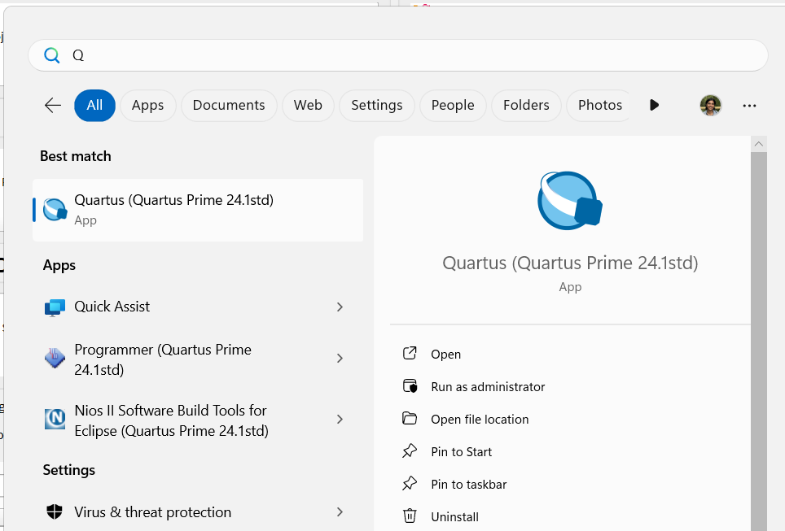

- You will see the home screen:
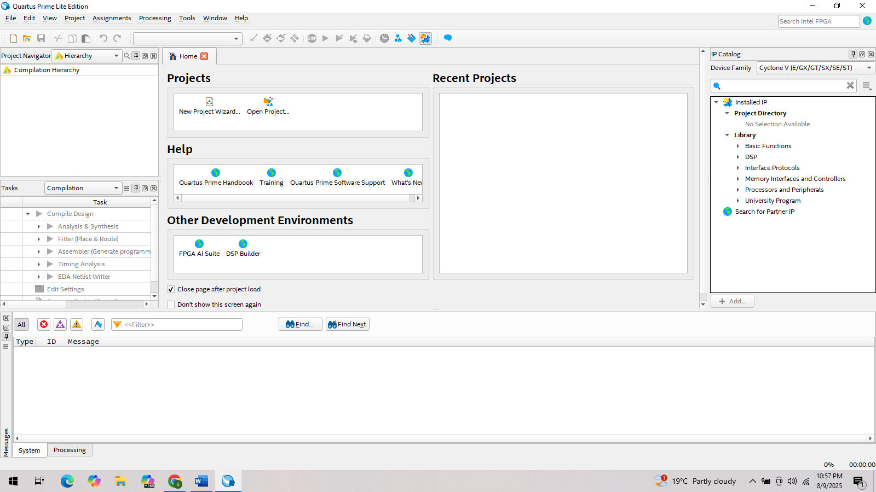
- Go to File -> New Project Wizard and follow the snapshots with the red rectangles as the wizard moves through various steps:
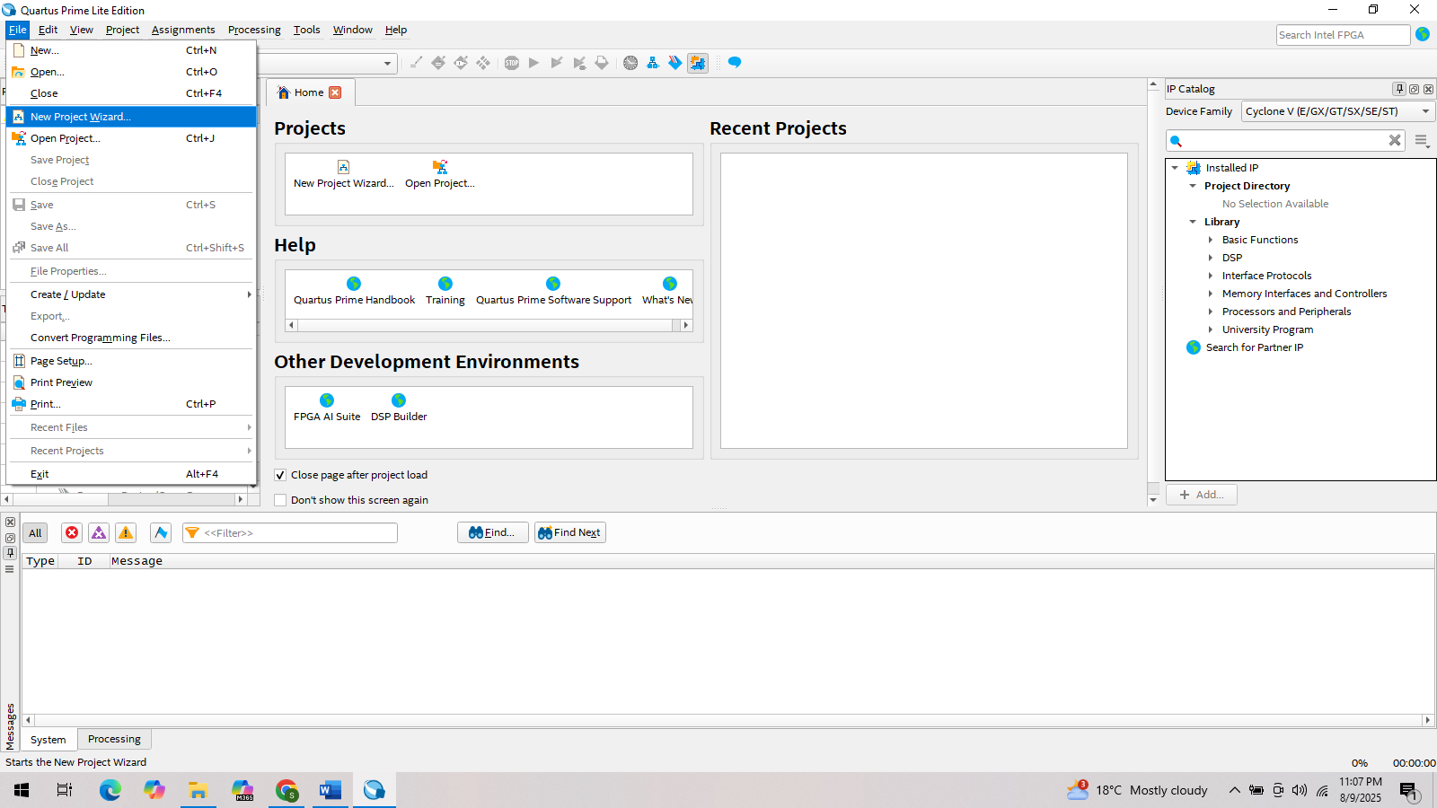
- In the working directory, navigate to the (sub) folder created in step 1. For me this is ‘path/Lab01/andgate2’. Enter the name of the project as andgate2. Note that I have kept this same as folder name. This will also be the top level design entity name for this project. Keep the naming consistent.
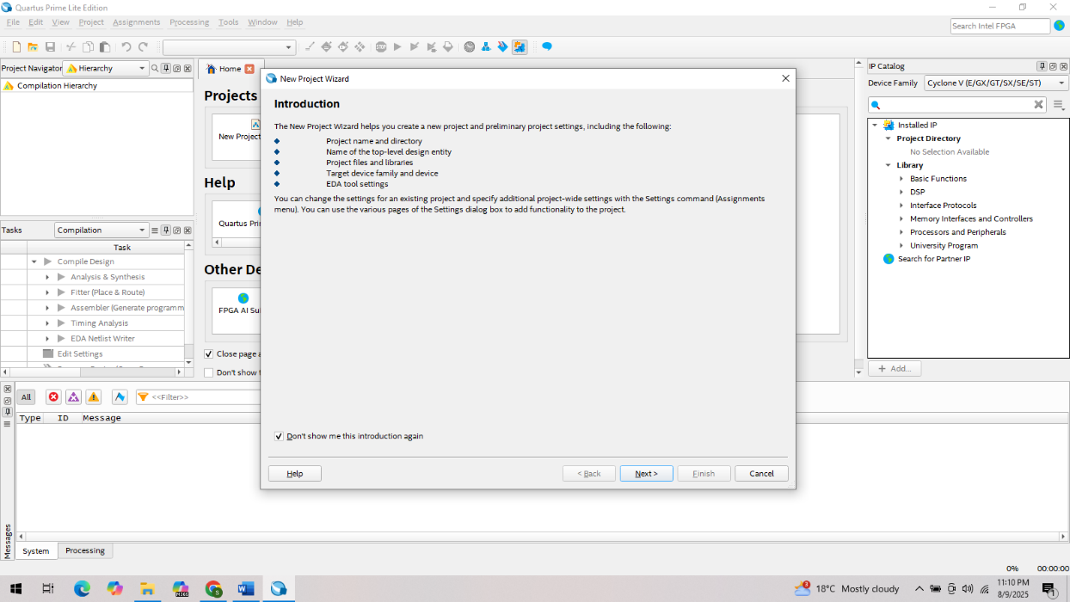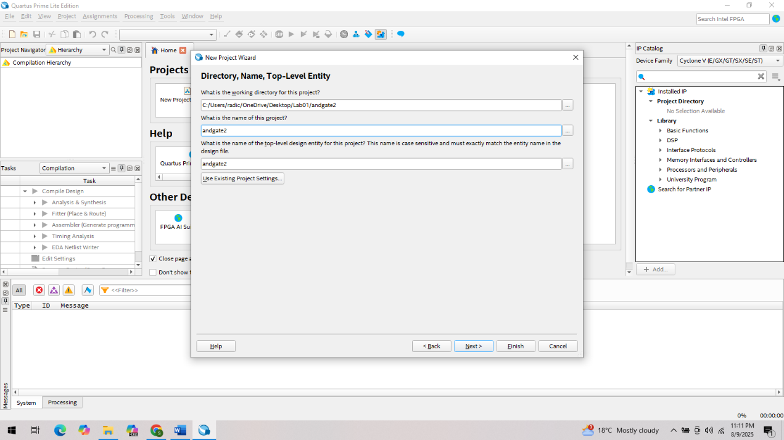

- The Project Type is ‘Empty project’. In Add Files, we want to add the verilog (.v) files that have been provided for each activity. Here we will add andgate2.v and andgate2_tb.v. Click on the ‘…’ button to the right of File name and browse to the project folder. Select both .v files to add them to the project.
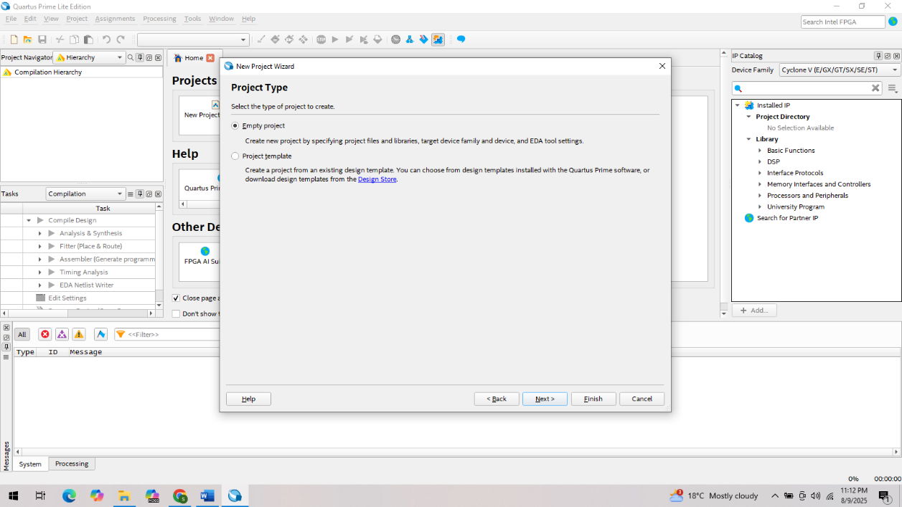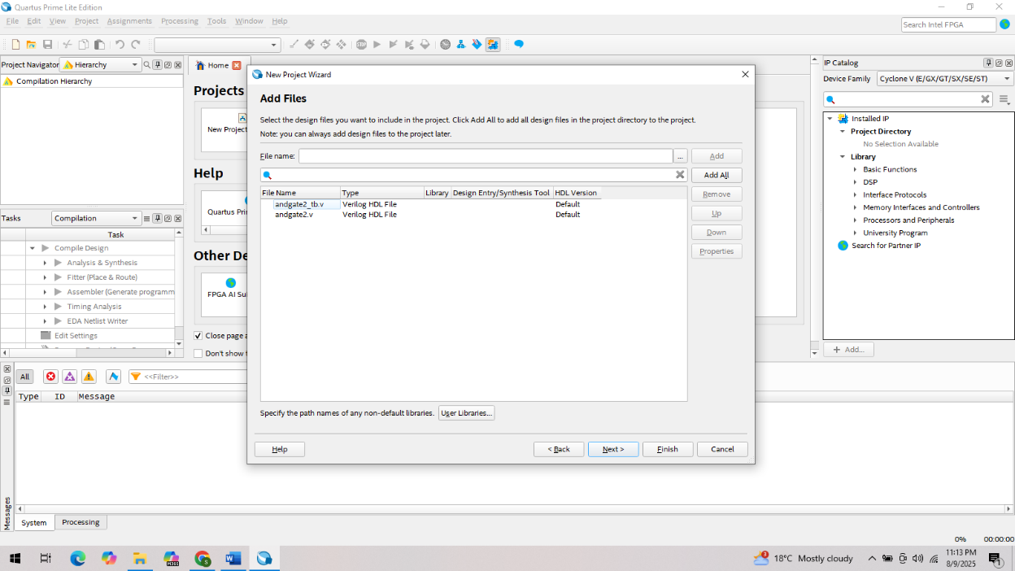
- In the Family & Device Settings page of the New Project Wizard pop-up:
Device family, Family: Cyclone V
Package: FBGA
Pin Count: 672
Speed Grade: 7_H6
Select Specific device selected in ‘Available devices’ list
From the list of available devices, select: 5CGXFC5C6F27C7 (You can also just type this in the ‘Name filter’).
Click Next
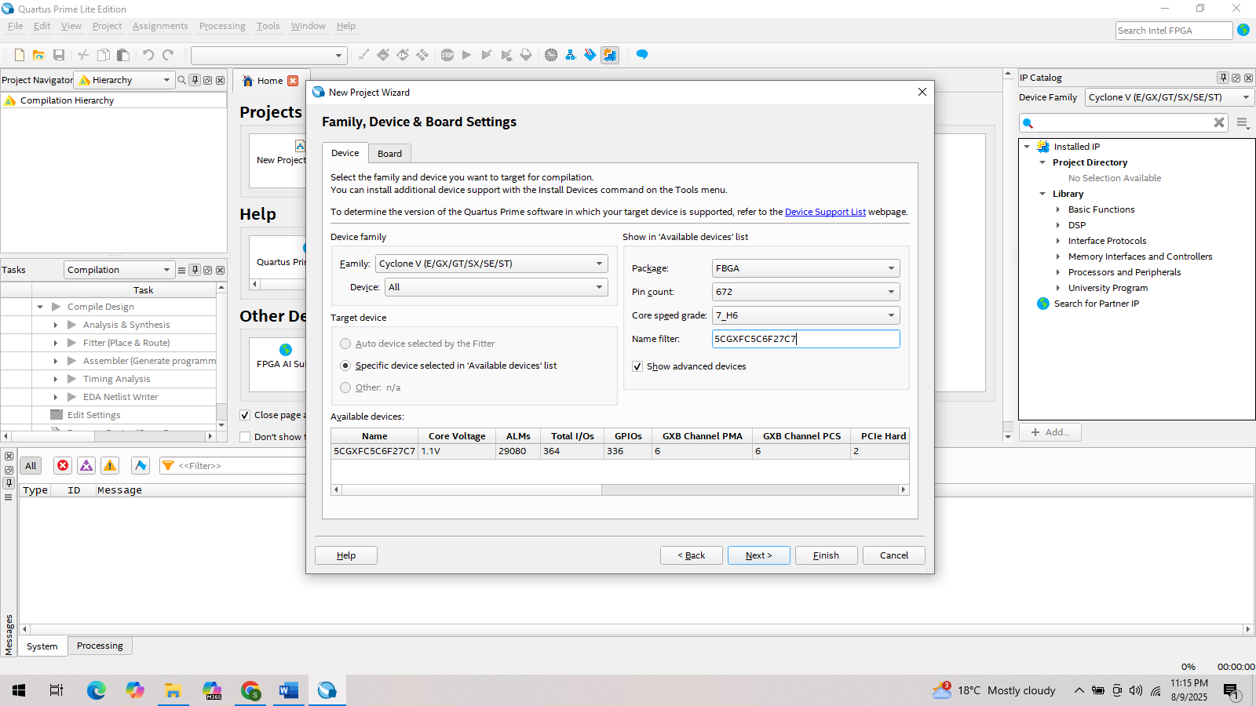
- In the EDA Tool Settings page, in the Simulation row, Tool Name column: Questa Intel FPGA, Formats column: Verilog HDL This should already show up as default. Don’t change any other defaults. Click Next. Review information on the summary page and if everything looks good, click Finish.
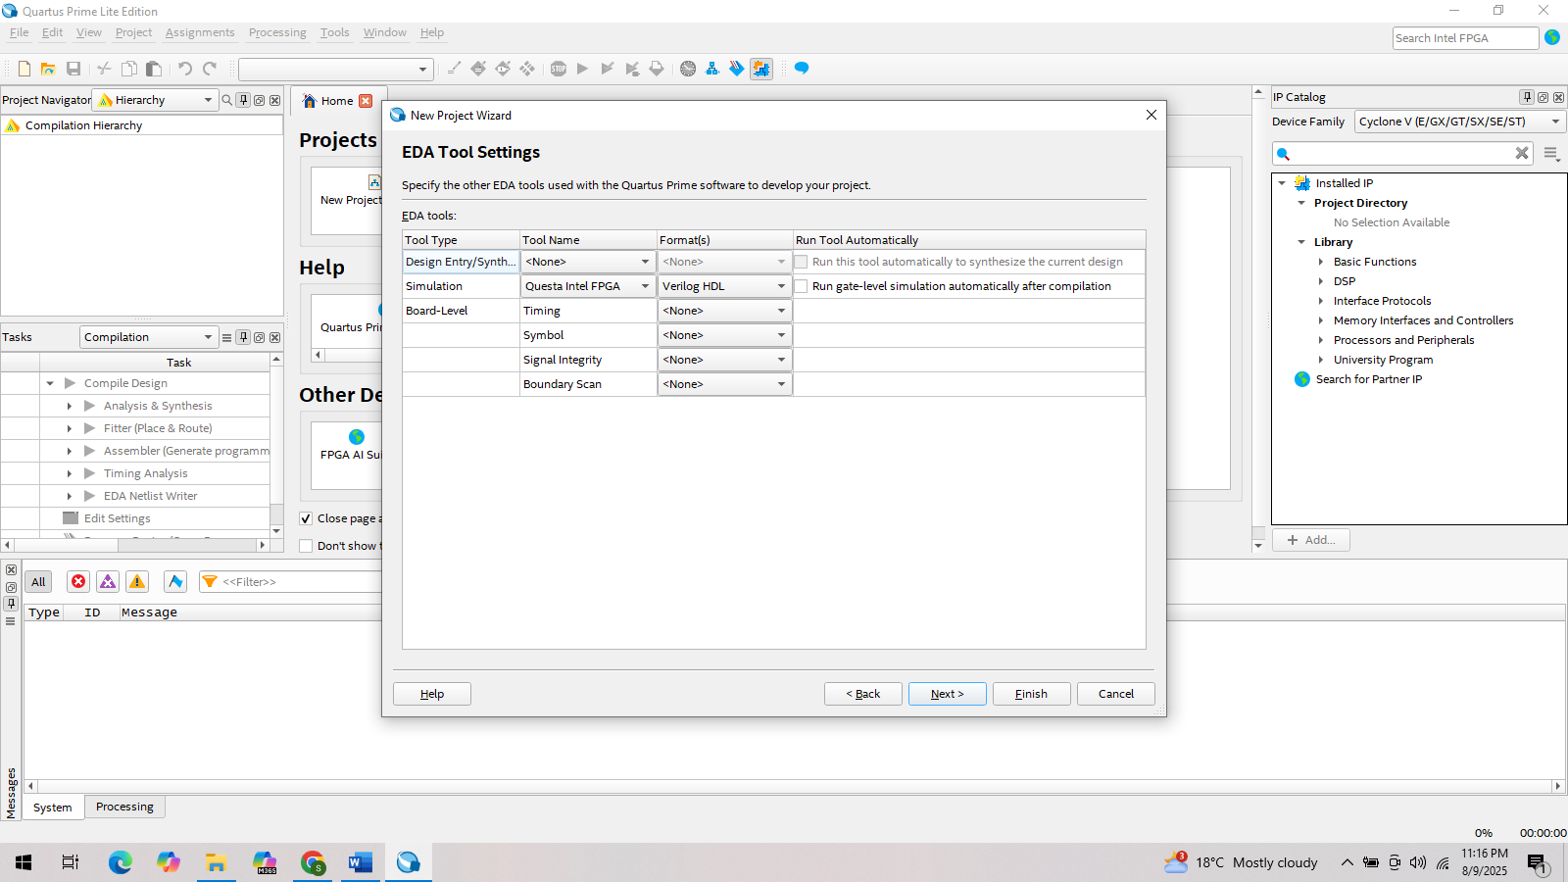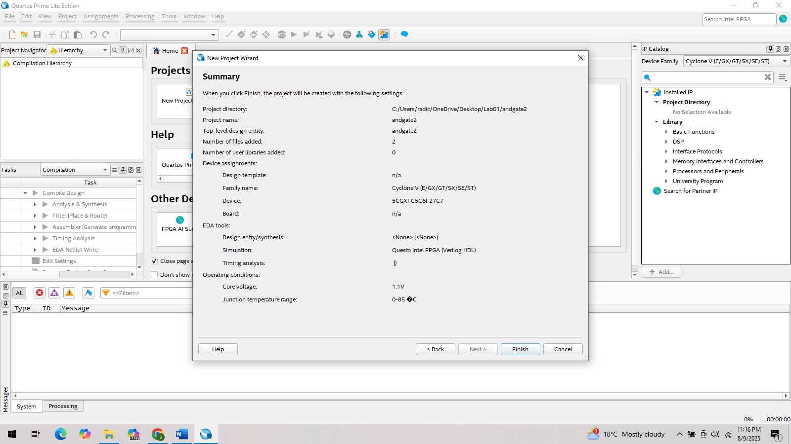
You will see something similar in the main Quartus window as below.
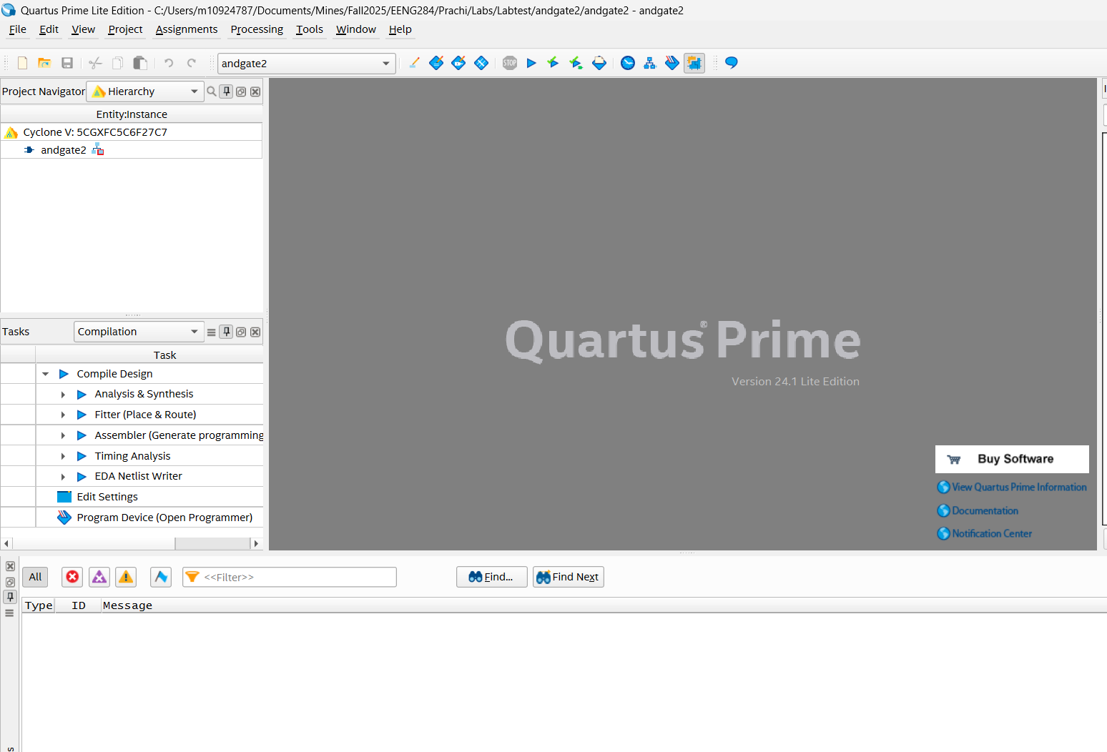
- You need to do this step only for the first time you build a project in Quartus. We are checking the setting for the simulator that we set in ‘How to install Quartus’. This step is just a check; there is nothing we need to edit.
Go to Tools -> Options-> General -> EDTA Tool Options -> EDTA Tool Column should be populated as ‘Questa Intel FPGA’ with the corresponding path as shown in the snapshot. Next, in this same window go to IPSettings -> License Set up. Use LM_LICENSE_FILE variable should be checked and the path to where you have saved the license file (emailed to you by SSLC) is correct.
